Azure VMs

1. Download and install .net 8
2. VS Code extension – C# dev kit
3. In vs code Open Folder
4. Create a .net application (For asp.net mvc)

<https://learn.microsoft.com/en-us/dotnet/core/tools/> - dotnet cli link

<https://learn.microsoft.com/en-us/dotnet/core/tools/dotnet-new> -dotnet new command link

1. Why VM’s

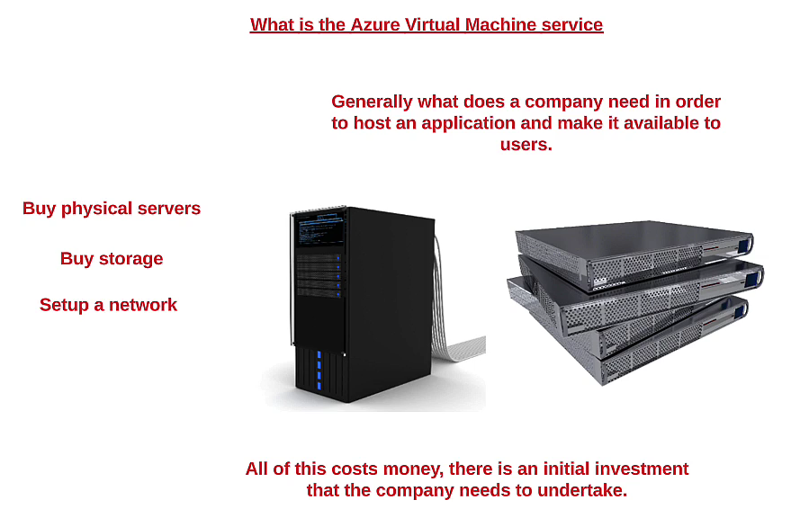

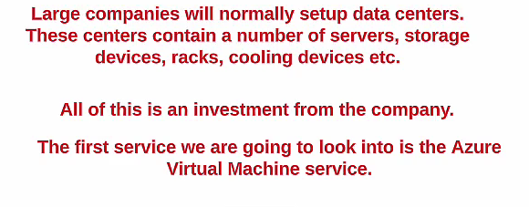

1. Azure VM’s

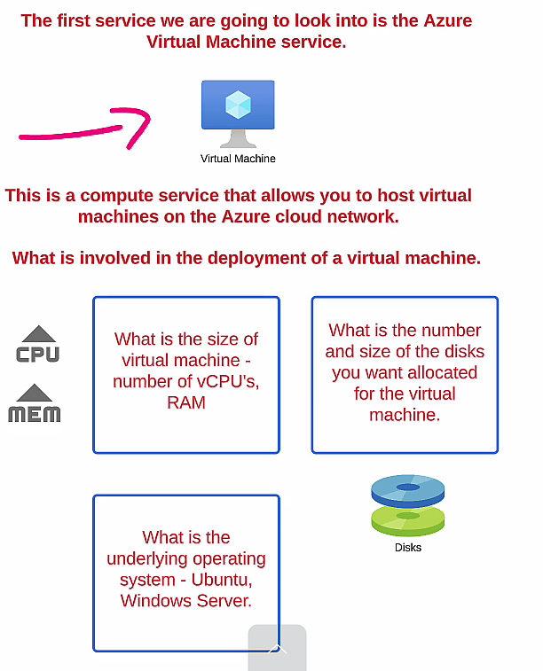

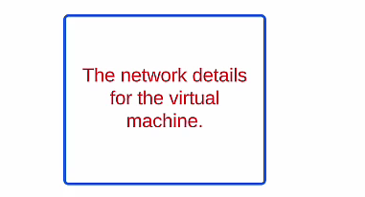

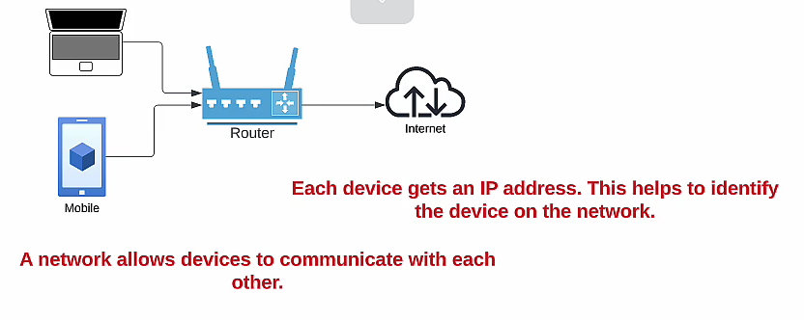

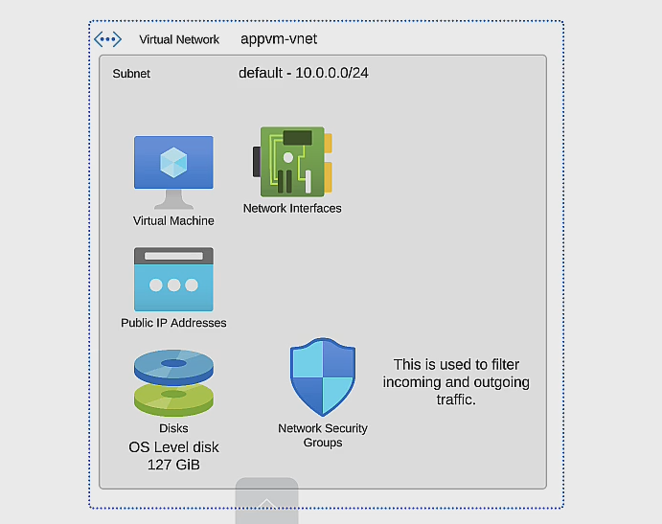

1. Deploying an azure VM

* Go To Virtual Machine from left panel
* 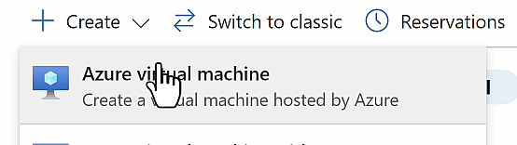
* 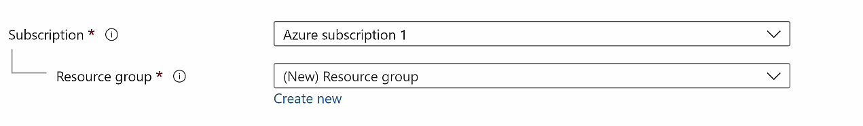
* 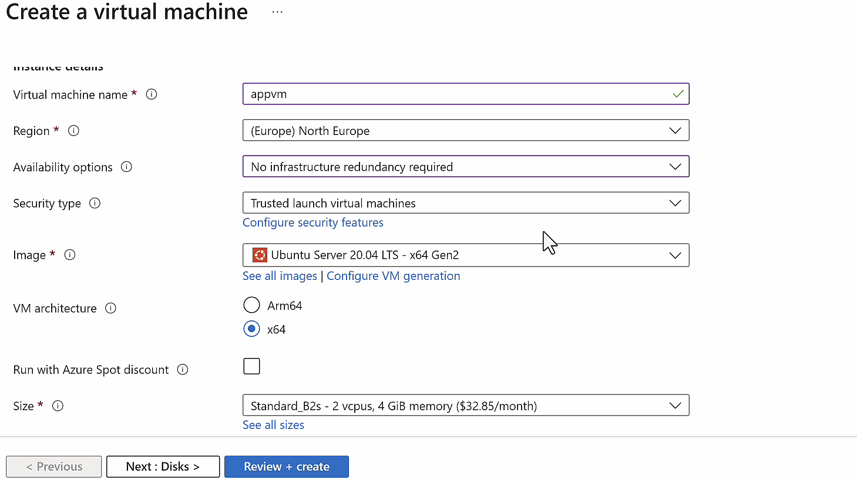
* Select image Windows server 2022 datacenter – x64 Gen 2
* 
* Specify username and password, keep it stored for further use

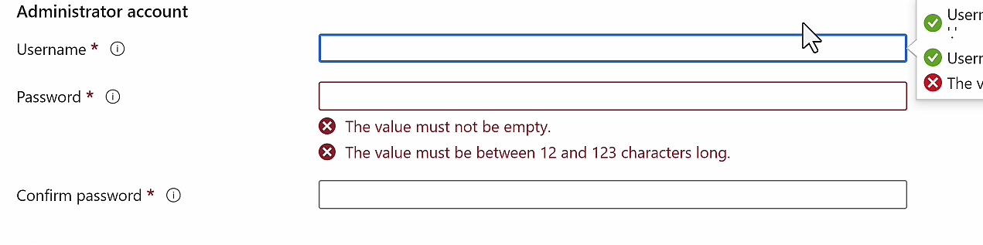

* Click on next till Review + create and create

1. Connect to a windows based machine

Go TO VM, Click connect and get native rdp file

**Hosting .net site on VM(Windows)**

1. Log into VM
2. Click on “Add roles and features”

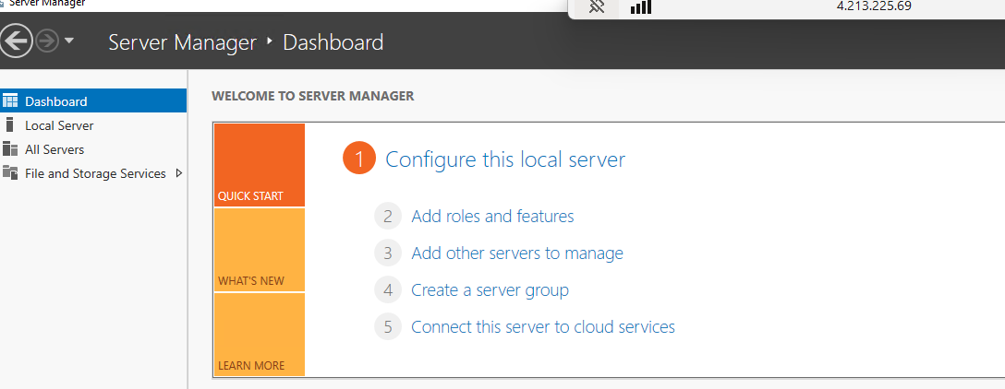

1. Click next and in “Server Roles” select “Web Server (IIS)” and click on add features

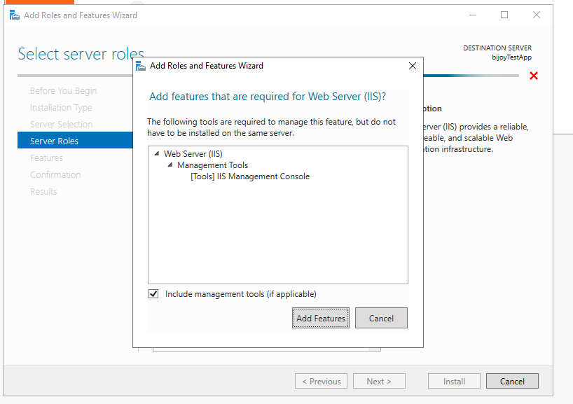

1. Hit http://public IP eg. <http://4.213.225.69/> in browser and default website is shown

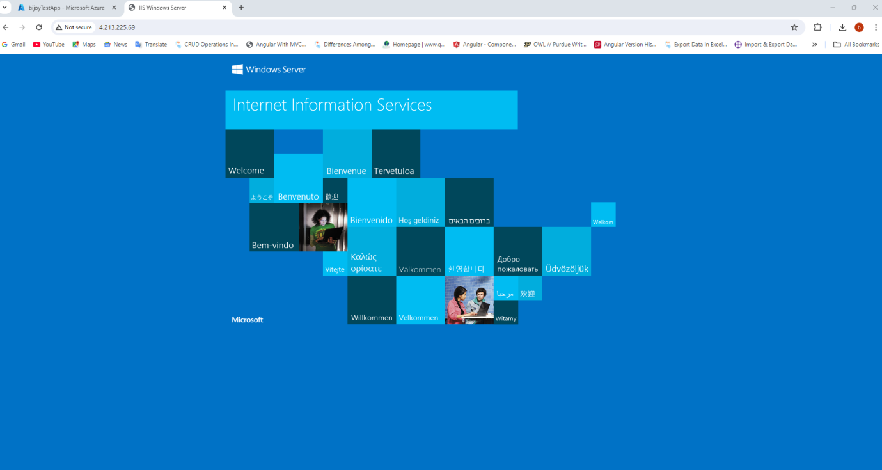

1. Search and install hosting bundle from internet

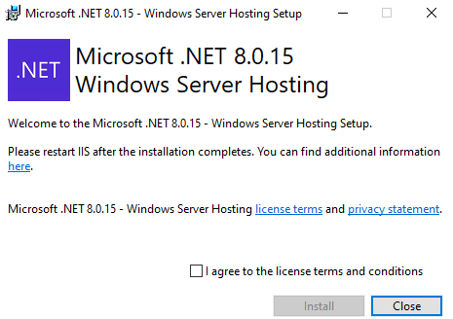

1. Create an .net core application and Run following command to publish the application in bin folder

“dotnet publish -c release -o ./bin/publish”

1. Close RDP connection… To copy from local to VM … right click on rdp file and click “edit”🡺Local Resources🡺Local Devices and Resources🡺more🡺Drives🡺E: or whatever drive the publich folder is in
2. Connect RDP and we can find local folder of our laptop in “This PC” of VM

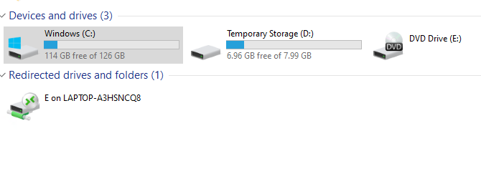

1. Disable default website by changing port of default wesite

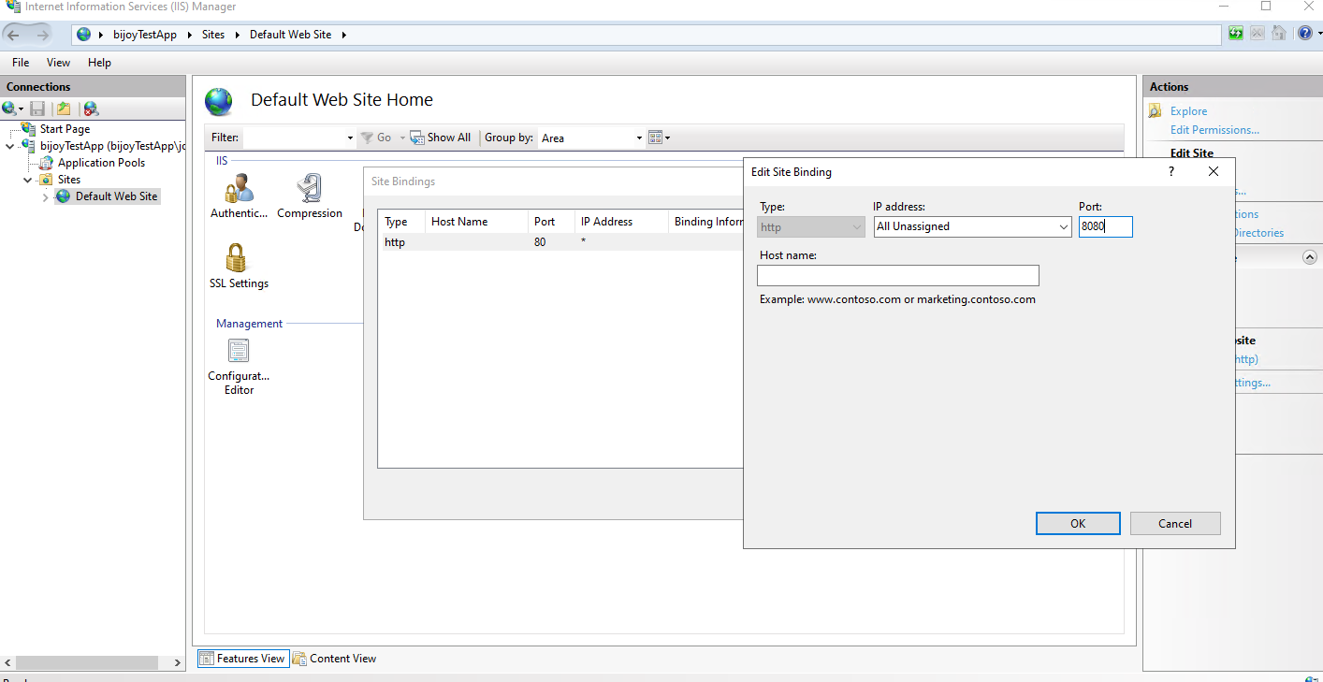

10 Create a new website, add path of copied code and port 80 and refresh page for our site to load.

